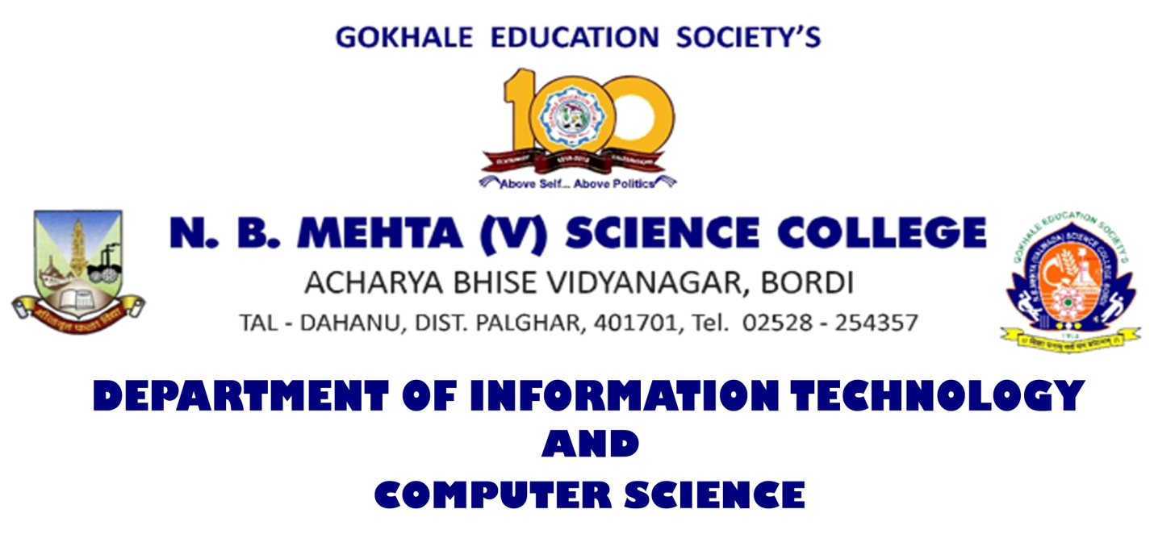

**Certificate**

Class ____________ Year ___________

This is to certify that the work entered in this journal is the work of

Shri/Kumari ________________________________________________________________

Of _________________ division___________________ Roll No. ______________________

Uni. Exam No. ___________________ has satisfactorily completed the required University of Mumbai Practicals on Subject PSCSP202: Natural Language Processing and worked for the Master of Computer Science 1st term / 2nd term/ both the terms of the Year _______________ in the college laboratory as laid down by the university.

______________________ _____________________ ____________________

Head of the External Internal Examiner

Department Examiner Subject teacher

Date: / / 2023 Department of IT-CS